**Project Design Phase-II**

**Technology Stack (Architecture & Stack)**

|  |  |
| --- | --- |
| Date | 17 October 2022 |
| Team ID | **PNT2022TMID31875** |
| Project Name | Project – IOT based safety gadget for child safety monitoring and notification |
| Maximum Marks | 4 Marks |

**Technical Architecture:**

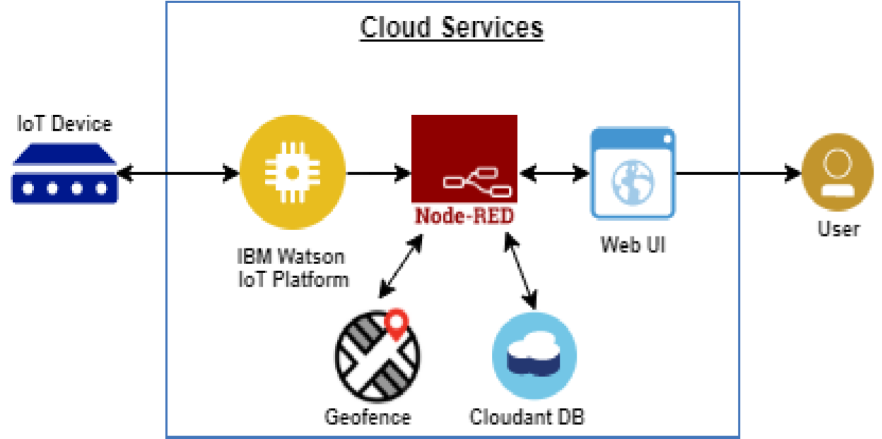

**Table-1 : Components & Technologies:**

|  |  |  |  |
| --- | --- | --- | --- |
| **S.No** | **Component** | **Description** | **Technology** |
| 1. | User Interface | The communication protocol being used in the proposed solution might act as an interface the way like WiFi, Bluetooth and ZigBee | MIT app |
| 2. | Application Logic | The data to be collected and sent to the  authenticator’s(parent) via GSM providing the GPS coordinates to easily locate access and monitor the child | IBM Watson STT service, python etc |
| 3. | Database | Data to be segregated and secured in the form of relational DBMS | MySQL |
| 4. | Cloud Database | IBM | IBM Cloudant |
| 5. | File Storage | File storage requirements | IBM Block Storage or Other Storage Service or Local Filesystem |
| 6. | External API-1 | To access the children location | GPS location monitoring etc |
| 7. | Infrastructure (Server / Cloud) | Application Deployment on Local System / Cloud Local Server Configuration | Cloud Foundry |

**Table-2: Application Characteristics:**

|  |  |  |  |
| --- | --- | --- | --- |
| **S.No** | **Characteristics** | **Description** | **Technology** |
| 1. | Open-Source Frameworks | The proposed solution being framed in the form an android application providing the end user an easy surveillance of their children (preferably users are parents) | UI/UX design developement |
| 2. | Security Implementations | The developed application should be accessible in the way it can only respond to the comments of the relevant users | Encryptions, IAM Controls. |
| 3. | Scalable Architecture | The app format comes the way easier to handle and operate. | Not yet determined |
| 4. | Availability | The developed solution tends to be available in the market at any time | Not yet determined |
| 5. | Performance | Highly proper and betterment functionalities are to be ensured in the designed solution | Not yet determined |